MySQL & DBMS Practical Assessment

Real-Time SQL Task Round

Duration: 40 Minutes

Total Marks: 60

Platform: MySQL Workbench

Assessment Scenario
You are working as a Junior Database Associate in an EdTech company.
Different departments have shared data requirements with the database team. Your task is to understand the business requirement and write the appropriate SQL queries.
This assessment is designed to evaluate:
- SQL understanding
- Logical thinking
- Requirement analysis
- Query writing skills

Important Instructions
• Use only the concepts taught during training
• Do not use JOINS or advanced SQL concepts
• Execute all queries before submission
• Paste only working queries in the submission form
• Avoid discussing with others during the assessment
• Small syntax mistakes may not reduce marks heavily if logic is correct
• Focus on understanding the requirement and writing the appropriate query
This assessment is intended to evaluate practical understanding and logical thinking. Focus on understanding the business requirement and attempting every task confidently.

Time Guidelines
Section | Recommended Time
Database Setup | 5 Minutes
Ticket #101 – Ticket #105 | 15 Minutes
Ticket #106 – Ticket #110 | 15 Minutes
Review & Submission | 5 Minutes

DATABASE SETUP

Step 1 — Create Database
CREATE DATABASE StudentDB;
USE StudentDB;

Step 2 — Create Table
CREATE TABLE Students (
student_id INT PRIMARY KEY AUTO_INCREMENT,
student_name VARCHAR(50),
age INT,
city VARCHAR(50),
marks INT
);

Step 3 — Insert Sample Data
INSERT INTO Students (student_name, age, city, marks)
VALUES
('Arun', 20, 'Chennai', 85),
('Priya', 21, 'Bangalore', 92),
('Rahul', 19, 'Hyderabad', 76),
('Sneha', 22, 'Chennai', 88),
('Kiran', 20, 'Mumbai', 67),
('Anjali', 21, 'Pune', 81),
('Vikram', 23, 'Delhi', 73);

PRACTICAL TASKS

Ticket #101 — Student Verification Report
The training department wants to review complete student details before certification processing.
SELECT * FROM Students;
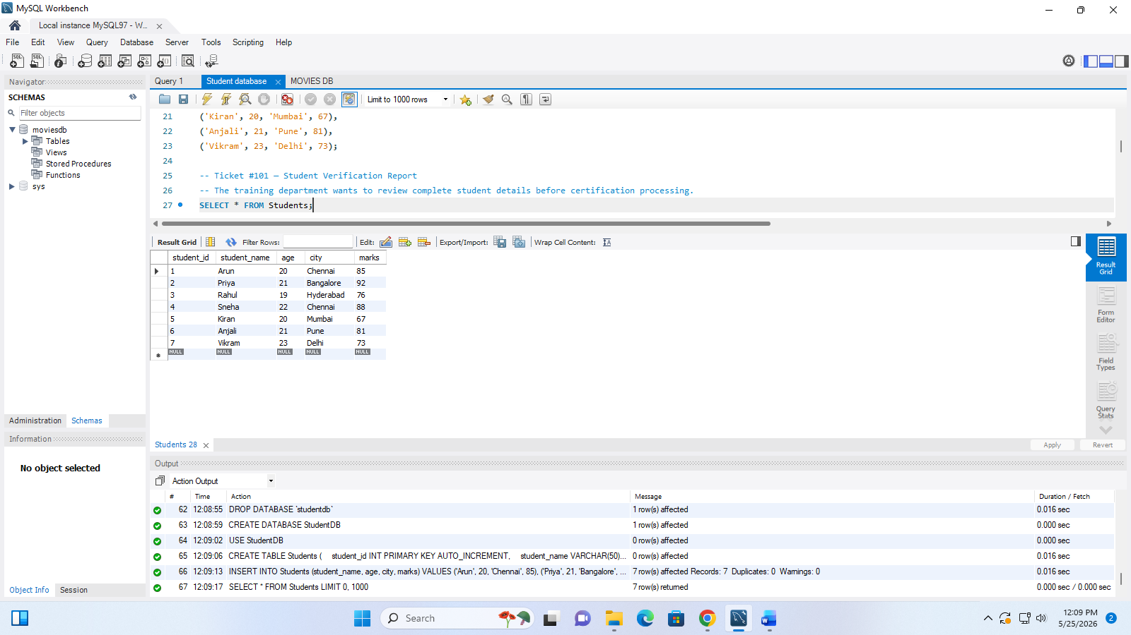

Ticket #102 — Chennai Operations Request
The Chennai operations team requested details of students enrolled from Chennai.
SELECT * FROM Students
WHERE city="Chennai";
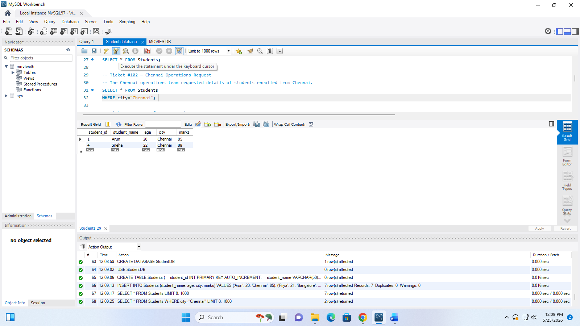

Ticket #103 — Performance Review
Management wants to review student performance from highest marks to lowest marks.
SELECT * FROM Students
ORDER BY marks DESC;
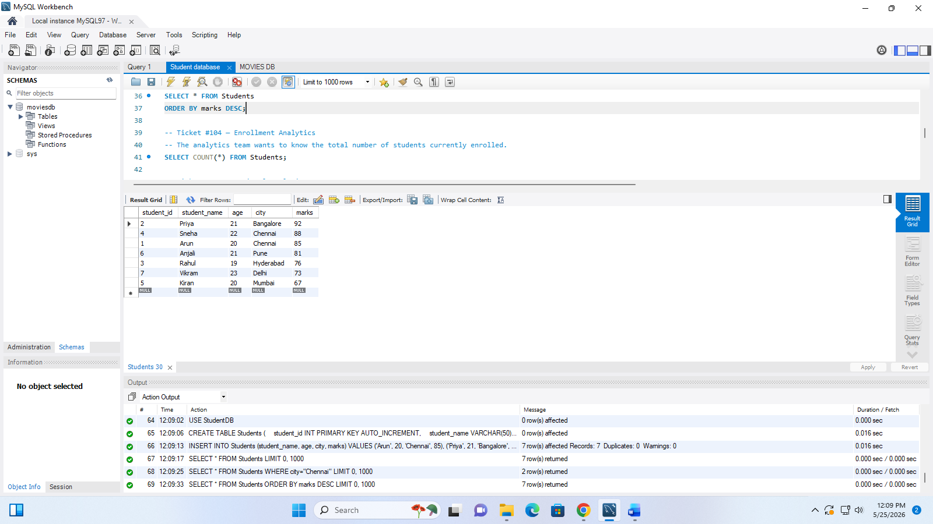

Ticket #104 — Enrollment Analytics
The analytics team wants to know the total number of students currently enrolled.
SELECT COUNT(*) FROM Students;
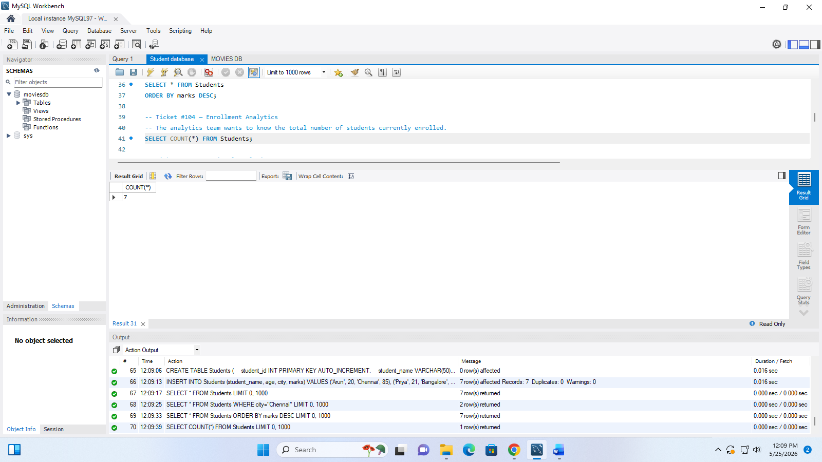

Ticket #105 — Regional Analysis
The business team wants to identify all unique cities from which students registered.
SELECT DISTINCT City AS Unique_cities FROM Students;
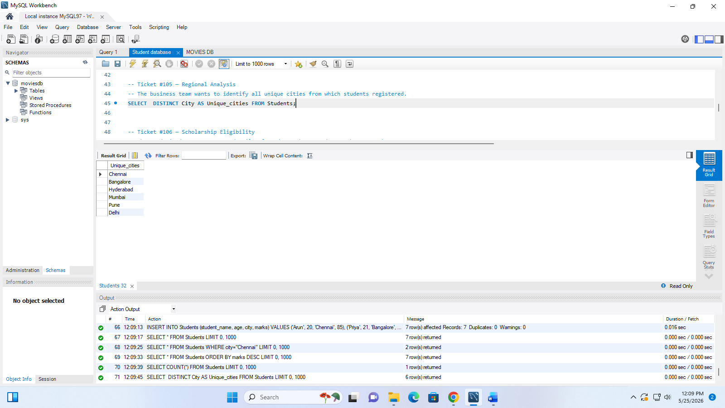

Ticket #106 — Scholarship Eligibility
The academic department wants details of students who scored more than 80 marks.
SELECT * FROM Students
WHERE marks > 80;
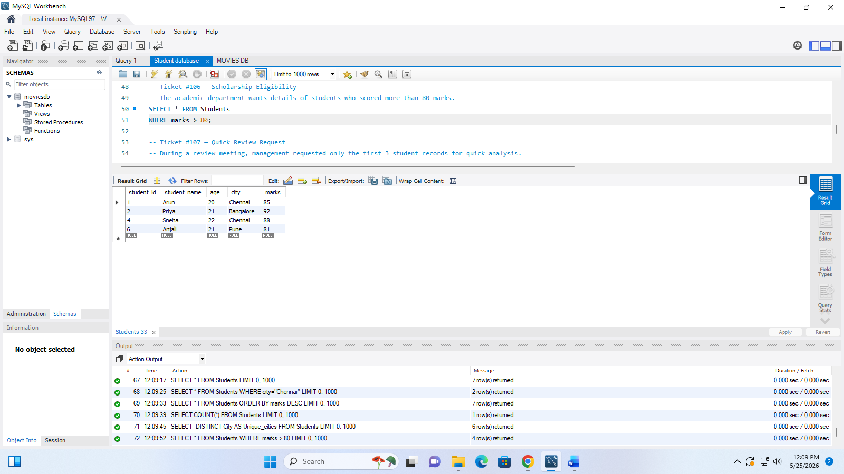

Ticket #107 — Quick Review Request
During a review meeting, management requested only the first 3 student records for quick analysis.
SELECT * FROM Students
LIMIT 3;
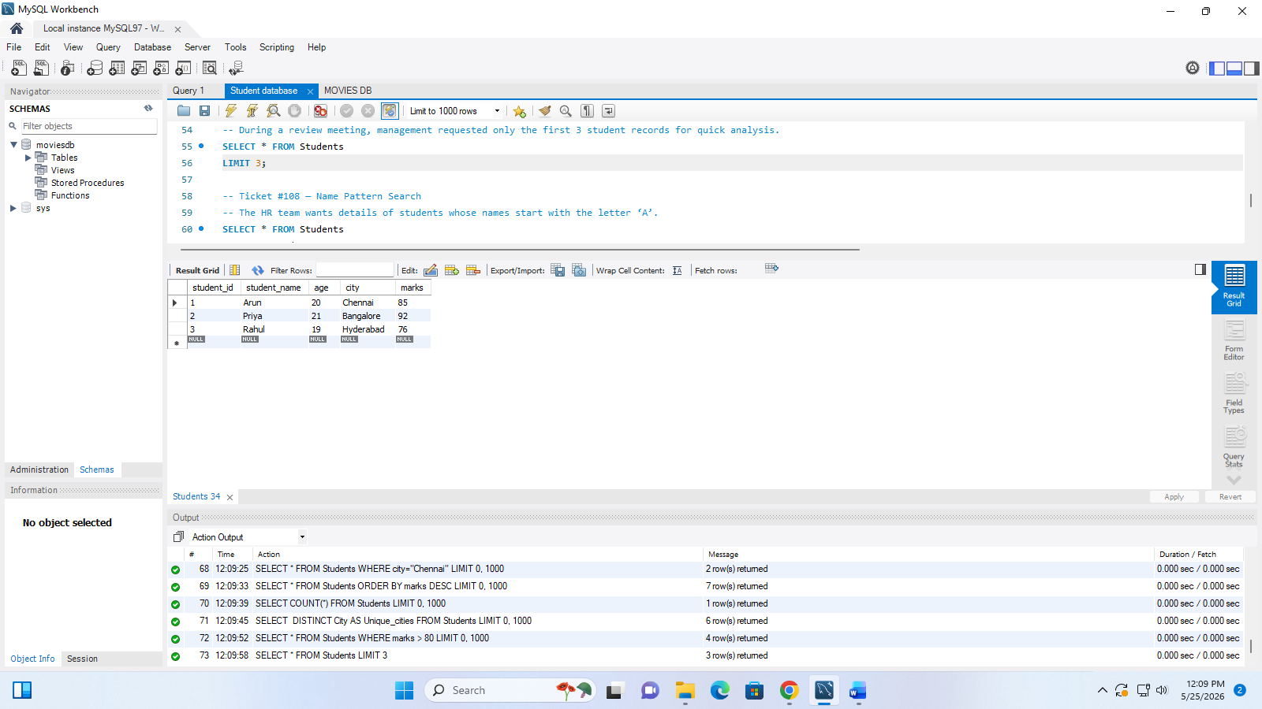

Ticket #108 — Name Pattern Search
The HR team wants details of students whose names start with the letter ‘A’.
SELECT * FROM Students
ORDER BY student_name ASC
LIMIT 2;
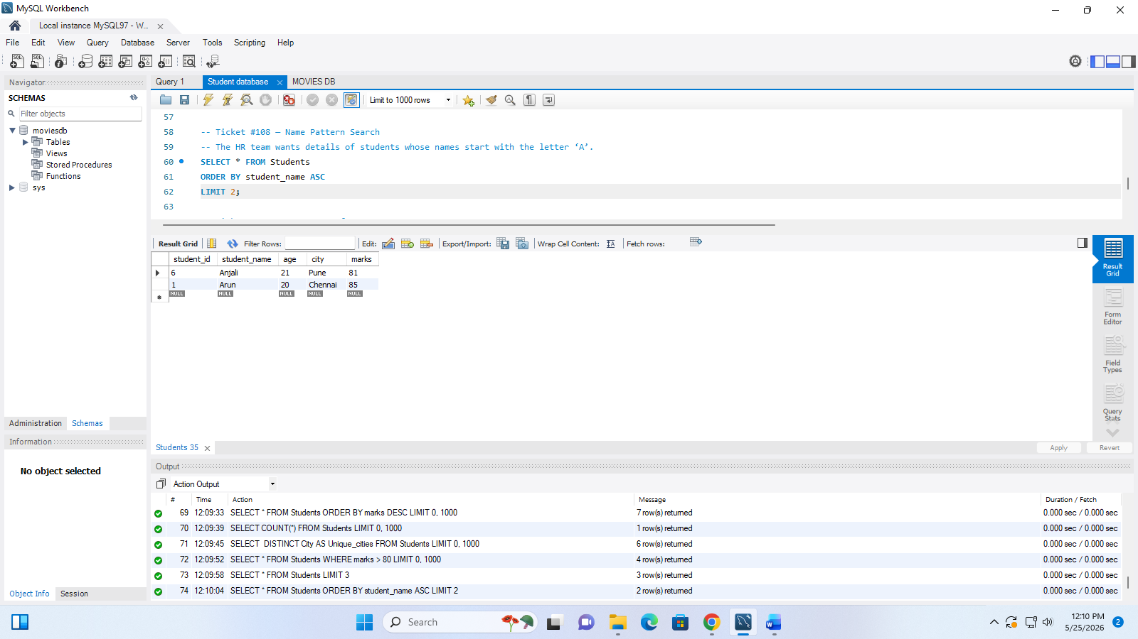

Ticket #109 — Average Performance Report
Management requested the average marks scored by students.
SELECT AVG(marks) AS average_marks FROM Students;
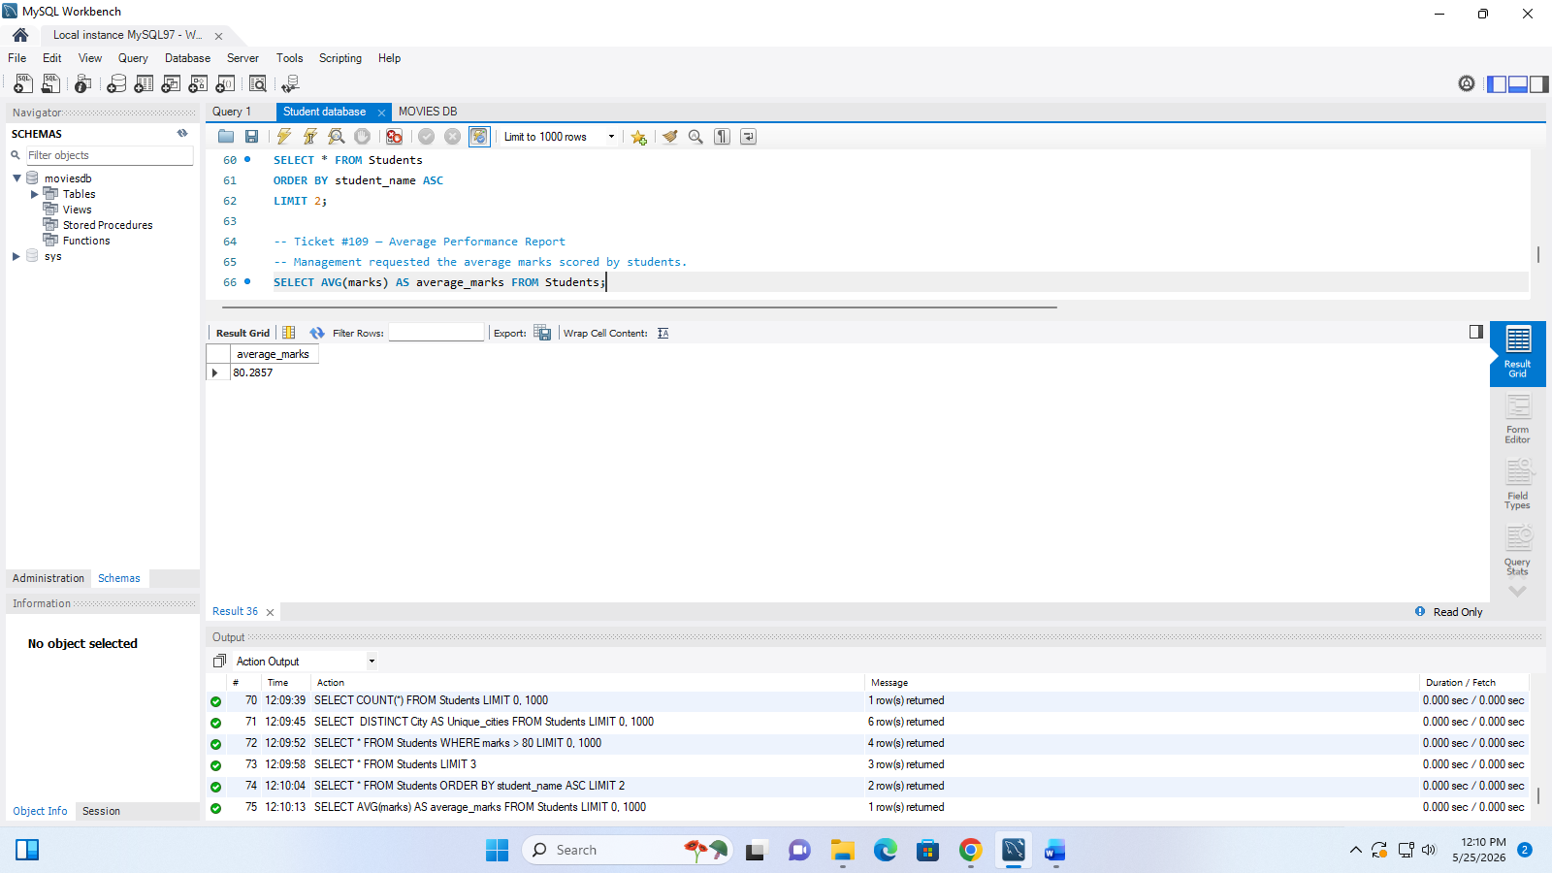

Ticket #110 — Marks Revaluation Update
After revaluation, Arun’s marks were updated to 95 by the academic team.
UPDATE Students
SET marks = 95
WHERE student_id =1;
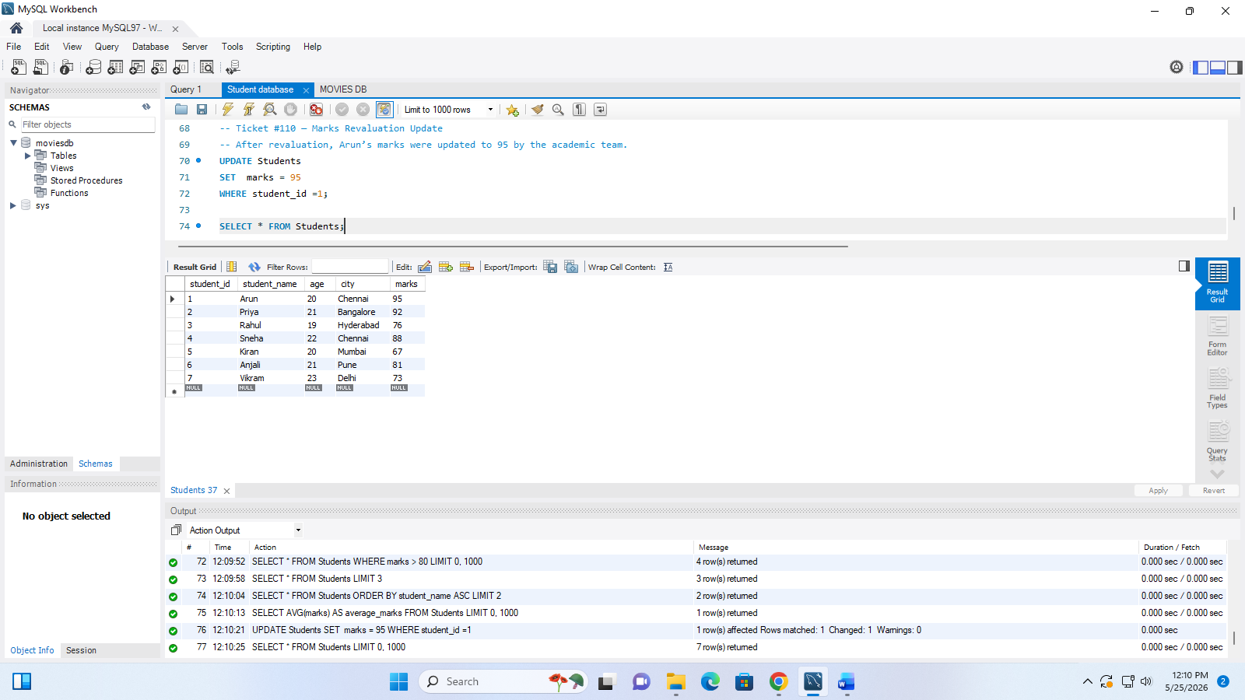

Submission Instructions
Students must submit:
- SQL Queries
- Output Screenshot (Optional but recommended)

Presentation Round
A few students will be selected randomly using a spin wheel.
Selected students must explain:
- Query logic
- SQL clauses used
- Requirement understanding
- Challenges faced during execution

